Flamingo Fashion
An extract
by Samantha Hunter
illustrations by Maggy Roberts

A lion then followed, nose in the air,
Snaking his tail side to side,
‘What can you do for a king like me?
I’ve got to impress my pride!'

‘A feathery headdress!’ said Freddie.
‘It’s the rage on the Copacabana.
We’ll style it with a bowl of fruits,
You’ll be seen across the Savanna!’
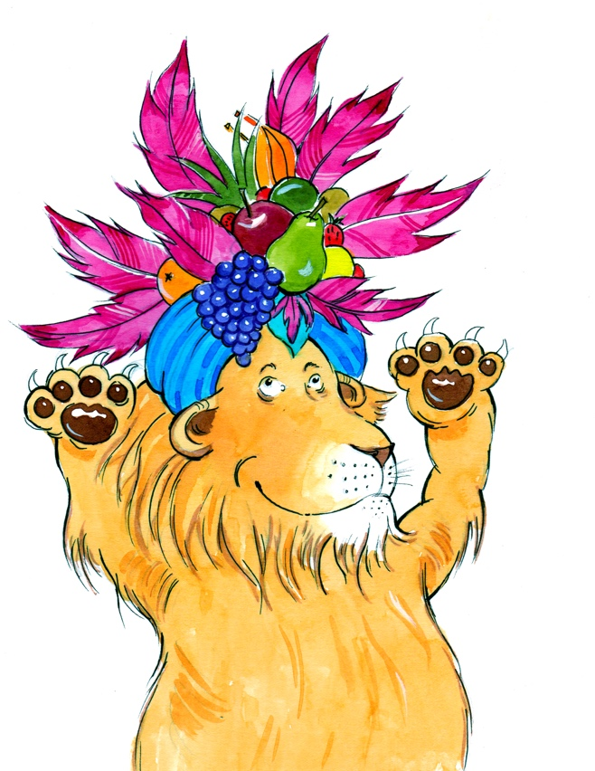
The lion ran his claws through his mane,
When he saw his fruity new hat.
He roared, ‘A crown that’s fit for a king,
I’m such a cool looking cat!’

